[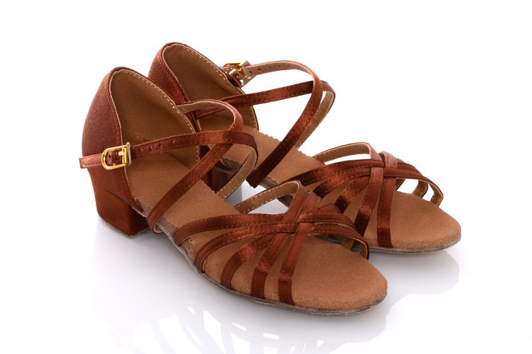](http://ru.aliexpress.com/item/Tape-cross-Latin-dance-shoes-dance-shoes-3cm-heel-gold-brown/729674969.html)