[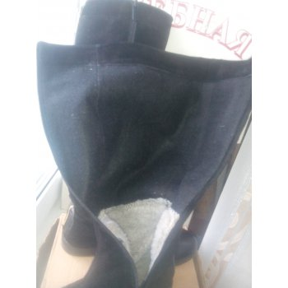](http://media.nn.ru/data/forum/images/2015-12/135796394-img_20151214_124933.jpg)