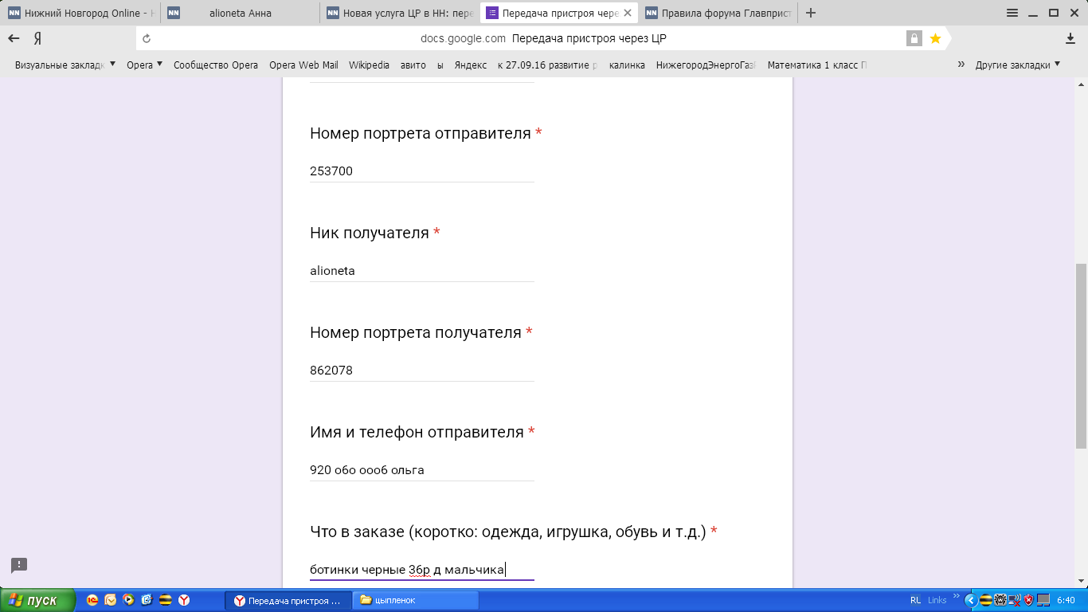

https://docs.google.com/forms/d/e/1FAIpQLSd-lihYFARzF2MGyRbGG2i-JPXhzmUsL_D-cCswHaO6S5yGgQ/viewform

