OPI Swiss Collection Fall 2010 Swatches

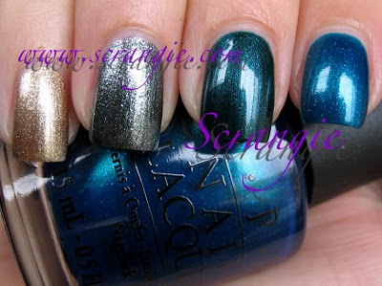
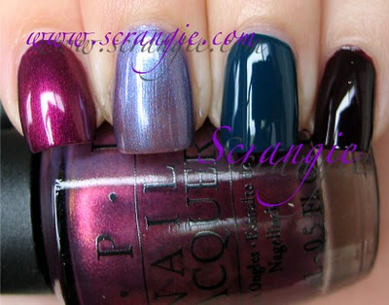
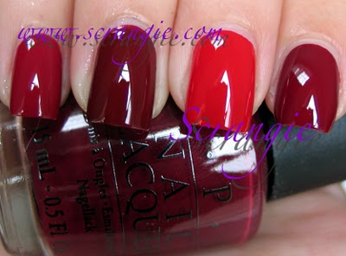
And the individuals (in sunlight):
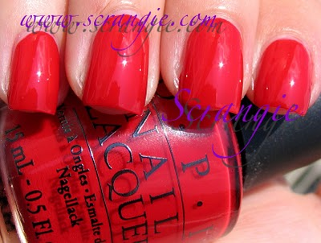Color So Hot It Berns. Bright clean red creme. A little Christmassy looking. I like these types of reds. Bright and crisp. Very simple and classic. Not much else to say about it!
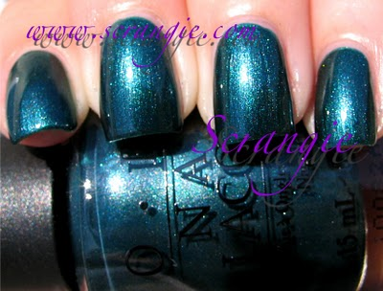Cuckoo For This Color. Sparkly medium blue-green shimmer. It's darker than it looks in this picture but I think this picture shows the sparkliness really well. It is similar to China Glaze Emerald Fitzgerald, but Cuckoo seems more blue to me. Almost a teal.
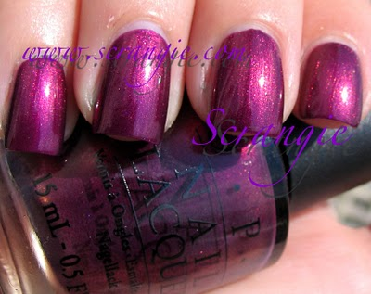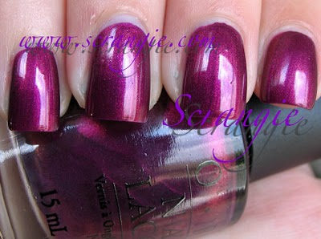Diva Of Geneva. So pretty. In my top five for this collection. Medium shimmering gilded plum. It's like a really red-based purple (mixture of purple and red-plum colored pearl) and lots of gold pearl, almost like a duochrome, you get glimmers of purple and gold depending on the angle. I had originally thought that LA Colors Pink Sizzle was a match for this color, but it turns out they're not really as close as I thought:
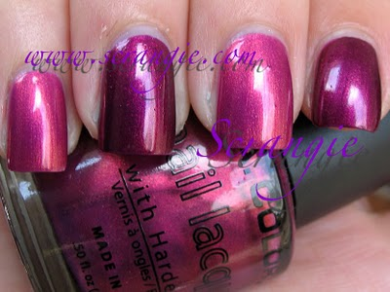They looked really similar in the bottle to me, but as you can see LA Color Pink Sizzle is much lighter and pinker.
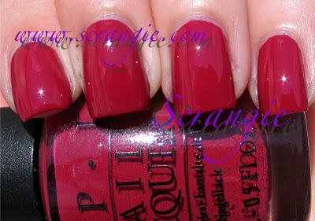From A To Zurich. Dark rose berry. Not really my thing.
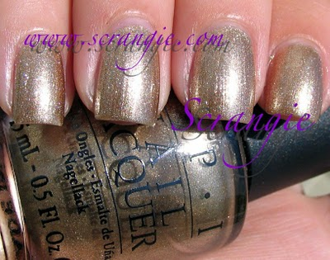Glitzerland. LOVE this. It's almost a champagne version of Dazzled By Gold, but not quite as sparkly. Still majorly sparkly, though! It's practically a foil it's so sparkly. You can see each individual shimmer particle, makes me think of champagne bubbles.
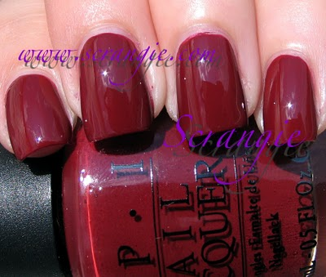I'm Suzi & I'm A Chocoholic. This is not really the color I think of when I hear chocolate! It's more red than brown, much more of a dark brick or maroon color than a chocolate color. Not particularly flattering on me but still nicer than Color Club Charity Ball.
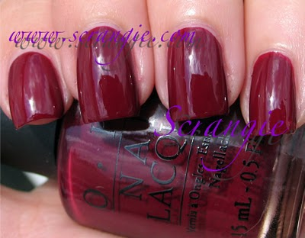Just A Little Rösti At This. My favorite of the least-favorites, haha! Another deep wine berry shade. Sorry about the clouds. I know this picture is pretty bad :(
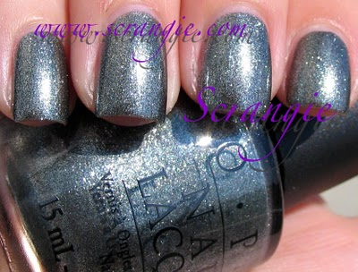Lucerne-tainly Look Marvelous! Marvelous, indeed. A smoky dark silver/grey foil. Near-foil really. Foils tend to blend into one sparkly sheet of color with hints of particles, but this one behaves more like a glitter showing every individual shimmer particle. Shimmer-glitter-foil! Similar to China Glaze Jitterbug.
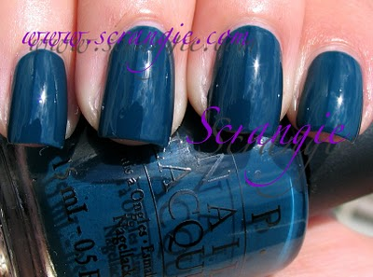Ski Teal We Drop. Oooh! A dark teal creme! We don't see these too often, especially not from OPI! I like. I like a LOT. Awesome color for fall. Makes me want to wear plaid.
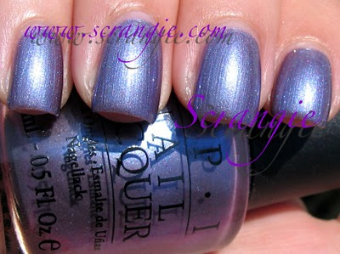The Color To Watch. Sheer light purple shimmer with strong blue pearl and microglitter. This is a pretty complex shade, lots of different colors mixed in. It looks like a duochrome but it doesn't seem to shift colors like one. I see all the colors at once. Blue pearl on top of lavender shimmer with silvery microglitter. This is the most sheer of all the colors- I used four coats.
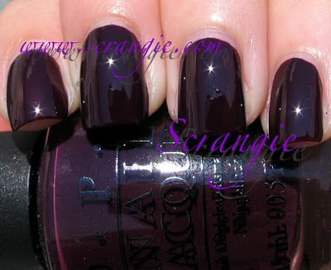William Tell Me About OPI. Deep, dark, luxurious, sexy vampy eggplant. Very nice. Very dramatic. I can see this one becoming the new Lincoln Park After Dark. In fact, I like this color better. This looks like it could have been in the Chicago collection!
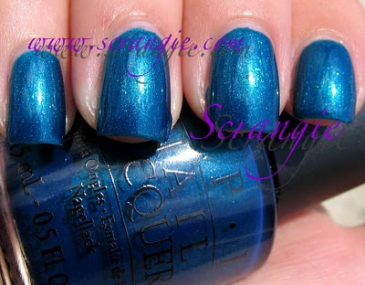
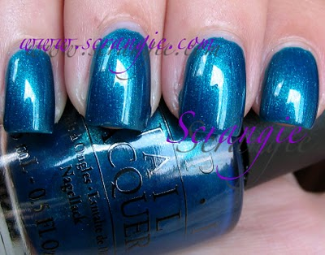Yodel Me On My Cell. This is my favorite of the whole collection. It's an aqua blue with lots of shimmer. It has small fine shimmer like a regular shimmer polish and then it has flecks of larger, more iridescent shimmer. Double shimmer! It makes me think of Catch Me In Your Net without the glitter. Has a kinda jelly-ish deep look. OPI does really good blues when they decide to do them!

