OPI Alice In Wonderland Collection Spring 2010
Wow... I was so excited about the new Nubar glitters that I forgot to post these yesterday! Oops!
I know these aren't my best pictures, but I had to work with the lighting I had... Less than ideal, but I managed to get a couple clear shots at least.
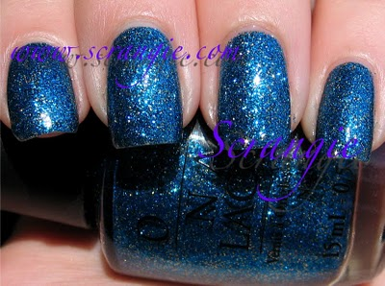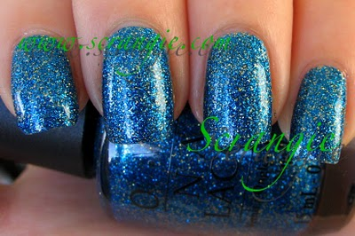Absolutely Alice. The color is accurate in the first picture, it's really not as light as it appears in the second picture, but the difference in lighting brings out the gold glitter that isn't as visible in the first picture. This is.... dare I say... the most gorgeous polish OPI has done since My Private Jet. OPI doesn't do glitters often, but when they do... they do them right! I can't even tell you how much I love this polish. I love it even more than China Glaze Dorothy Who? In case you can't tell by the pictures, this is a vibrant medium blue with a splash of shiny gold glitter. It is insanely sparkly.
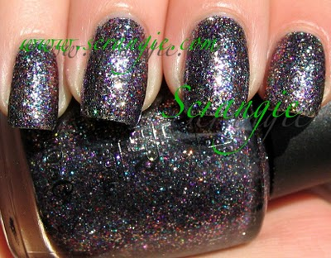
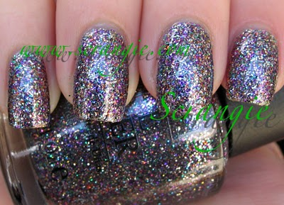Mad As A Hatter. Another perfect polish. This is a multicolored glitter. The base looks silver or blackish in these picture, but I don't find that to be the case when I look at my nails in real life. The silver does appear dominant, but what it really reminds me of is Rescue Beauty Lounge Frugalista with a little rainbow glitter tossed in. The purple and silver stand out to me the most, but there's also green and blue and gold and red, maybe a few other colors I can't pin down. The overall effect is a jewel-encrusted look. HOT.
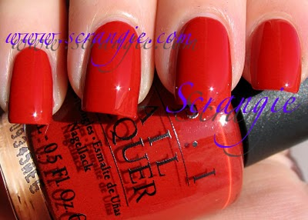Off With Her Red! An orangey-red creme. This has a soft quality to it- it's not super bright and crisp, it's a little bit dusty. Similar feel to OPI Bullish On OPI. Orangey, dusty. Not terribly exciting but not bad either.
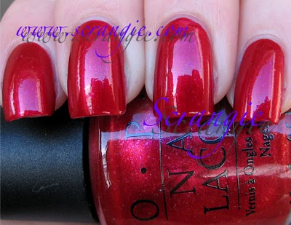Thanks So Muchness! This is not really a great shot of this, but if you enlarge the picture you can see the interesting detail in the finish. This is your average medium red shimmer with the addition of some light pink shimmery broken flakes. Like someone took a handful of the Nfu Oh flakes and crushed them. Very cool, kinda similar to the 90210 red from Valentine's Day.... I forget which one had the flecks... Pretty & Privileged? This is a lot like that one.
I thought the formula on these was great. Everything was opaque in two coats and applied like a breeze. I have good luck with OPI's formula. I did two coats of everything in these pictures. You can see a tiny bit of nail through the glitter (toward the tips but not really on the nail plate) with two coats, but not enough that it inspired me to do a third. A third coat would probably make them even better, though.
The glitters *were* a huge pain to remove. I normally don't have a problem removing glitter- if anything, they just take a little longer. But for these, they took three times as long. I don't know what's different about these that makes them so much tougher to remove. And, since I've been asked a few times... I don't do anything special to remove glitter. I find that a cotton ball or two soaked with Zoya Remove+ is enough to remove them fairly quickly. Sometimes if I'm feeling lazy I'll use the tub with the bristles, but I find that that takes longer than just cotton balls most of the time. Well... I guess I do one special thing to remove glitter... Here's a confession. Sometimes I peel it off. Thankfully it has no adverse effect on my nails, but... yeah. LOL
I'm extremely happy that OPI took a risk and did some AMAZING glitters instead an entire collection of safe colors. I only wish that the two reds were glitters too!

