OPI Fall 2009 Coleccion de España
OPI's polishes for fall 2009 are another destination-themed collection. This time it's based on the colors of Spain.
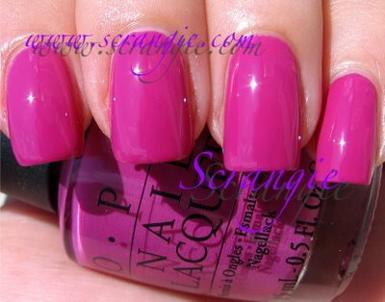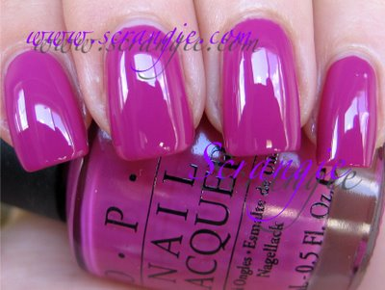Ate Berries In The Canaries. Bright berry pink. Really pretty and surprisingly bright for a fall collection! It's a gorgeous bright pink-purple creme. The sunlight picture pulls out more of the warm tones in the polish while the indoor picture brings out the cool tones. It's in between the two. More pink than purple, a little bit similar to OPI I'm India Mood For Love. Same type of color.
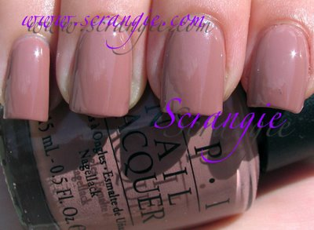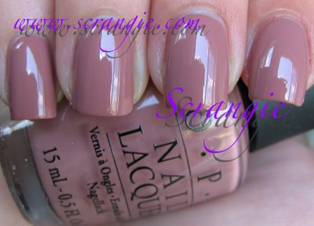Barefoot In Barcelona. Soft pinkish nude. Another spin on Rescue Beauty Lounge Grunge? This one is very putty-like. Odd color. I can't decide if I like it or not. In some lights it seems more brown, in others more pink. It's unusual, but we're seeing more of these colors lately, so I guess it's not as unusual now...
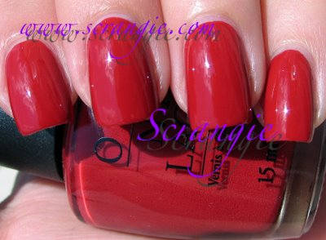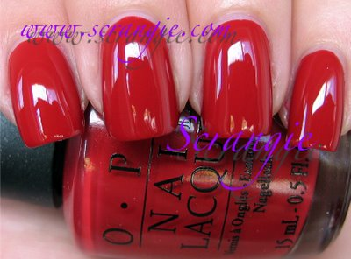Bullish On OPI. Red-orange creme. This is more orange than red, maybe what I would consider 'brick'. This one feels more like fall to me. I don't get the name... maybe it's a play on words? The only thing I think of when I read "Bullish" is "Bullshit" but I don't think that's what they meant. Intentional or not, I got a laugh out of it!
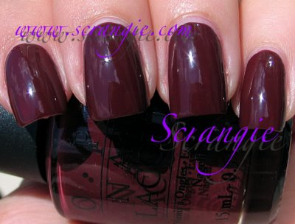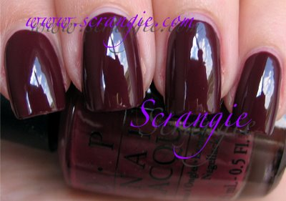Can You Tapas This? Red-brown creme. Like chocolate and red wine! Or maybe mole. Not the animal, the sauce. I really like this one, this one is also more of a fall shade.
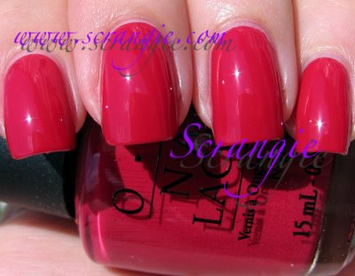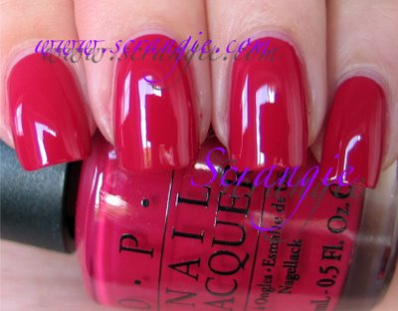Conquistadorable Color. Raspberry creme. Not really very interesting, I feel like I've seen this color a million times. It's bright, it's smooth, it's candy-like. Next!
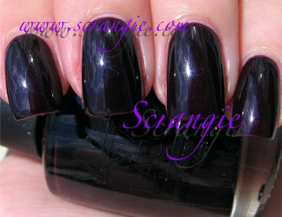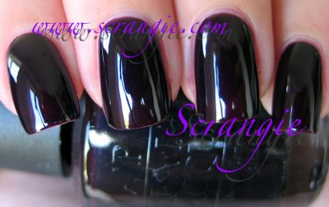Give Me Moor! Vampy eggplant shimmer. This is really very dark, almost black. Black cherry... Eggplant... A dark, vampy shade with a reddish-purple tinge. It also has barely noticeable shimmer. Applying this is strange- it's a sheer base with a lot of little dark speckles!
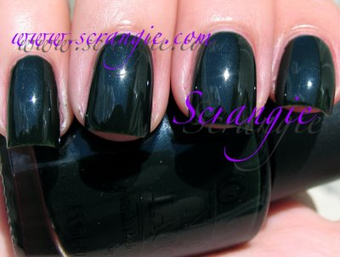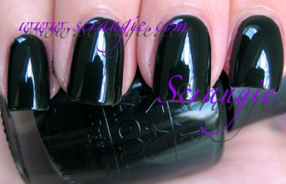Here Today... Aragon Tomorrow. Very dark green with slight shimmer. WOOHOO!!! A real green! OPI did a green, I knew they had it in them! This is just a bit darker than I had hoped, but at least it's green. It does look almost black in most lights. It has a small amount of shimmer like Give Me Moor! but it looks like a speckled creme most of the time.
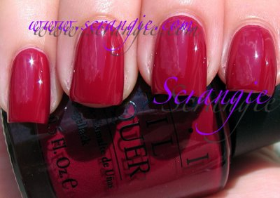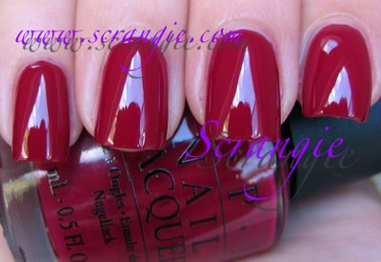Manicurist Of Seville. Berry red creme. Nothing wrong with the color at all, but don't we have enough berry-colored cremes already? I'm getting a little sick of them, to tell you the truth... Moving on...
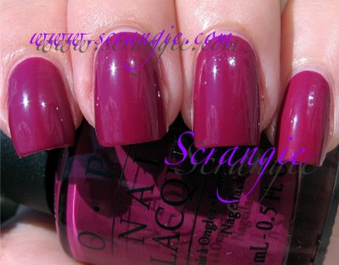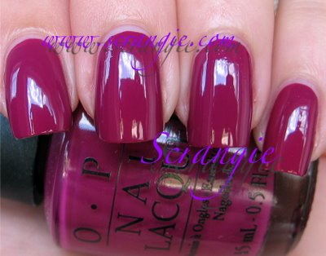No Spain, No Gain. Red-purple creme. Wow, almost all cremes. I'm surprised! Anyway, this is mostly purple to my eye, but it's a very red based one. So red based, in fact, that it's also veering dangerously close to berry territory.
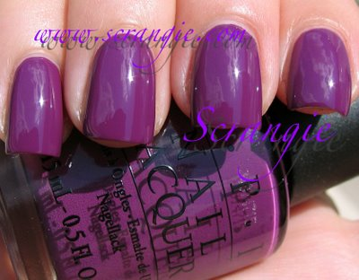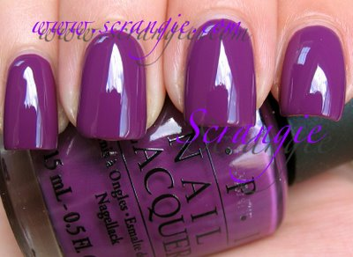Pamplona Purple. Purple creme. This is gorgeous!! Absolutely gorgeous! Like I've said before, I can never get enough purple cremes and this one is especially nice. My picture makes it look way more blue than it actually looks in real life. It's not a Can You Dig It? dupe, I'd call it closer to that one from the France collection, the name escapes me at the moment...
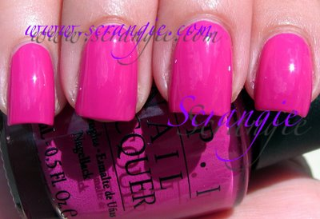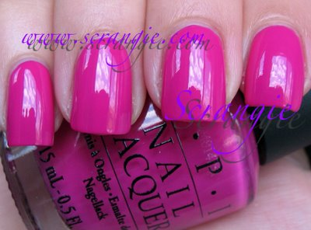Pink Flamenco. Hot blue-toned pink. Another love! And another odd choice for fall. Seriously, brights for fall? Has OPI been drinking too much Sangria? Well, I'm not usually happy about pinks, but I love this one. It's the only type of pink that looks good on me. It's only a couple shades off from Ate Berries In The Canaries, but this is more purple and that one is more pink. Same kind of I'm India Mood For Love cool pink shade.
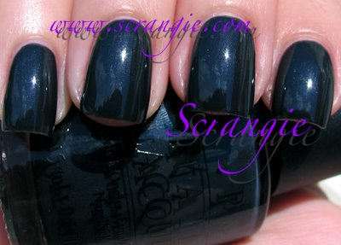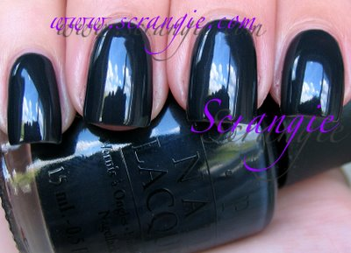Suzi Skis In The Pyrenees. Smoky dark blue shimmer. Very strange shade. It looks smoky. Crazy smoky blue. I really don't have many shades like this, this is definitely unique in my collection. The closest comparable colors I can think of are Orgasm Hard Day's Night and Carolyn New York Frankie Joins The Navy, but neither are dupes. So a smoky blue-grey base with barely perceptible shimmer, a lot like the other hidden shimmer shades in this collection.

