OPI Retro Fun In The Sun Revisited
It seems like it was about this time last year that this collection came out. I had gotten my own camera and was just learning how to use it. Needless to say, my pictures were horrible.
This was such a good collection, it really deserves better pictures. Let's try this again.
OPI Retro Fun In The Sun Collection - Summer 2008
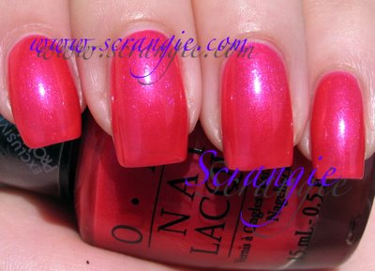Calendar Girl. A shimmery magenta with a blue/purple flash. It has lots of little sparkles, but it's not quite as sparkly-looking as the other polishes in the collection. The blue flash is what makes this one special.
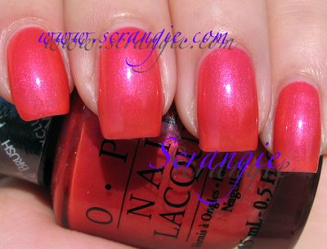Give Me A Coral Sometime. Shimmery coral. This one is actually not too different than Calendar Girl. It is lighter and has more of an orangey tint instead of pink. It also has a little bit of a blue flash.
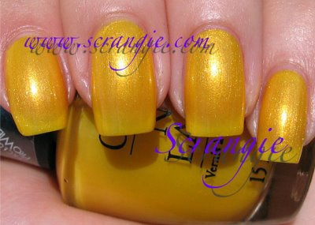Lemonade Stand By Your Man. Shimmery lemon yellow. This one is a stunner! It's so bright and cheerful, and in the sunlight it looks like it's candy. It has so many little sparkles in it, almost like it's coated in sugar.
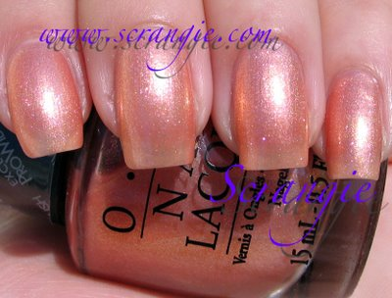Peach-A-Boo! Shimmery, duochromey peach. This polish is really unique. It changes colors depending on the angle. It has a peach shimmer base, but flashes of gold, red and silver. Very, very, very pretty.
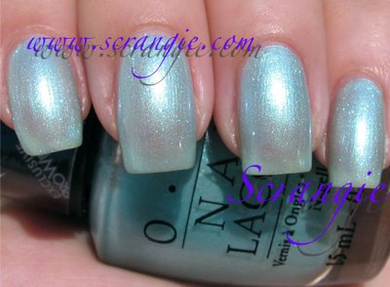Sea Ya Later, Sailor! Sheer sparkly light blue. This is a bright, beachy, watery light blue. Reminds me of swimming pools and beach balls. It's really sparkly, and one coat of it reminds me a lot of Chanel Azur. Would be great for layering.
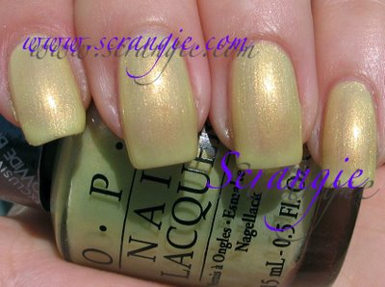Sit Under The Apple Tree. Light golden-green shimmer. This is an unusual color. It's very light green apple green with a strong golden flash. It leans very yellow, and looks more yellow than green until you get to three coats.

