New OPI Designer Series shades!
They're finally here!! The nine new OPI Designer Series polishes are here at last and it's instant love. I'm a sucker for holographic polishes, and while these are different from your average holo, they're still beautiful and mesmerizing.
On to the swatches! As always, I leave these huge to show you the detail, so please click the images to enlarge them.
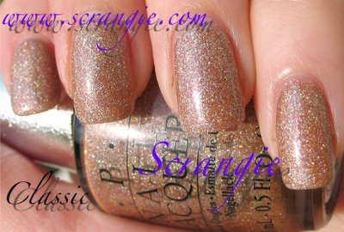
Classic. A warm gold holographic polish. As you can see, it's more of a 'scattered' type holo, as opposed to other holographic finishes like the China Glaze Kaleidoscope and OMG collections or previous OPI Designer Series polishes.
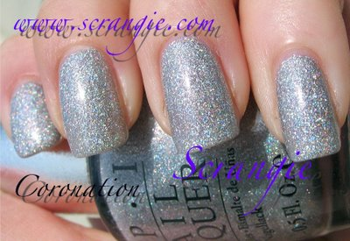
Coronation. A bright silver prismatic holo. It's similar to polishes like China Glaze Sexagon and OPI Paris Couture For Sure, but as you can see it's that scattered type of shimmer.
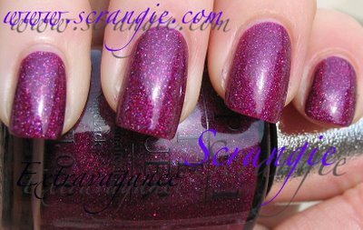
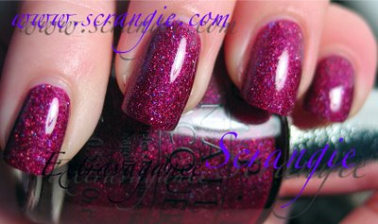
Extravagance. This one was so pretty it needed two pictures. One outside, one inside under fluorescent light A rich purple with incredible shimmer. Stunning, and a must-have for purple lovers like me!
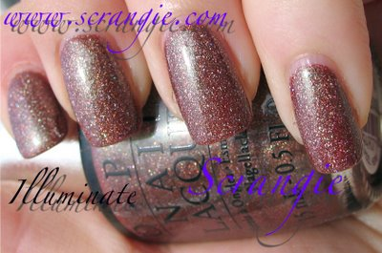
Illuminate. A fascinating holographic brown with green duochrome! Holo and duochrome? I'm not sure if I can handle the awesomeness!
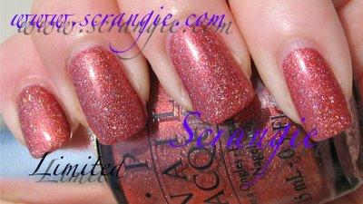
Limited. A warm coppery-pink sort of shade with holographic shimmer. These aren't glitter, for all of you who are wondering. They're perfectly smooth, silky, sparkly shimmer polishes and they're not the least bit gritty or chunky.
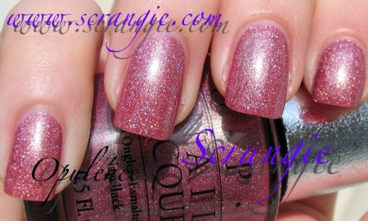
Opulence. Very flattering mauve-pink with holographic shimmer to keep it from being plain. It's a pink I would wear!
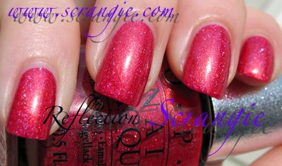
Reflection. Wow!! I'm not sure how to describe this color.... Hot pink coral with gold duochrome and holo? It's extremely eye-catching and just one hell of an excellent shade. This one was even opaque in one coat, but I did two anyway.
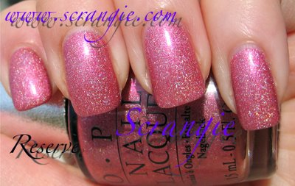
Reserve. Another pretty holographic pink- very feminine and flattering but not the least bit boring!
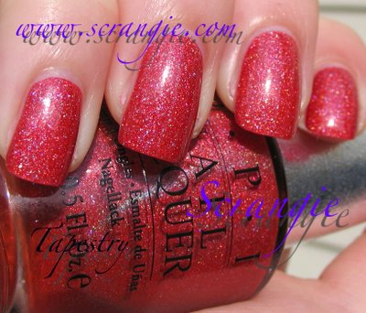
Tapestry. For some reason I want to call this shade 'russet' and I have no idea why. It's sort of a pink-red, more on the red side than the pink side. Loaded with holographic shimmer. Reminds me a little bit of OPI Crim-sun but not as holo

